PROJECT DEVELOPMENT PHASE
Date | 31 January 2025
Team ID | LTVIP2026TMIDS73798
Project Name | Online Payments Fraud Detection Using Machine Learning

5.1 Performance Testing
Performance testing evaluates how well the machine learning model performs in detecting fraudulent transactions.

5.1.1 Model Building
The model was built using the Random Forest Classifier, a supervised ensemble learning algorithm.
Steps Involved in Model Building
- Import necessary libraries
- Load dataset
- Separate features (X) and target variable (y)
- Split dataset into:
  - Training set
  - Testing set
- Initialize Random Forest classifier
- Train model on training data
5.1.2 Model Training Process
During training:
- The model learns fraud patterns from historical transaction data.
- Multiple decision trees are constructed.
- Each tree contributes to final classification.
Training Logic:
- Input: Transaction features
- Output: Fraud (1) or Legitimate (0)
The model calculates fraud probability using:
model.predict_proba()
This probability is later used for risk classification.
5.1.3 Performance Evaluation Metrics
To evaluate model performance, the following metrics were used:
- Accuracy - Measures overall correct predictions.
- Precision - Measures how many predicted frauds were actually fraud.
- Recall - Measures how many actual fraud cases were detected.
- F1-Score - Harmonic mean of precision and recall.
- Confusion Matrix
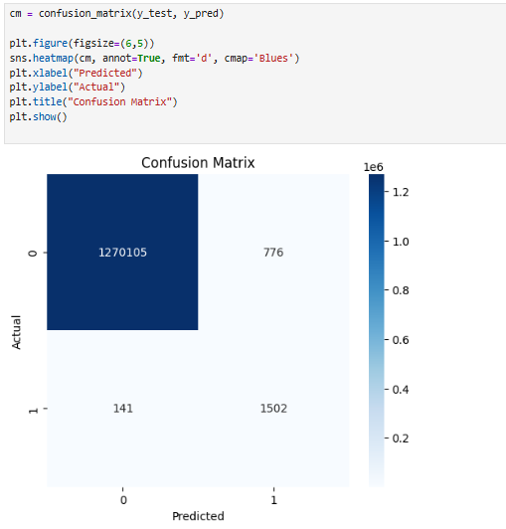
Confusion Matrix Interpretation
 | Predicted Legitimate | Predicted Fraud
Actual Legitimate | True Negative | False Positive
Actual Fraud | False Negative | True Positive

5.1.4 Model Performance Outcome
- High overall accuracy achieved
- Good fraud detection capability
- Reduced false positives
- Suitable for deployment
The model was then saved using Joblib for web integration.

5.2 User Acceptance Testing (UAT)
User Acceptance Testing ensures that the system works correctly from the user's perspective.
5.2.1 Frontend Interface
The frontend was developed using Streamlit.
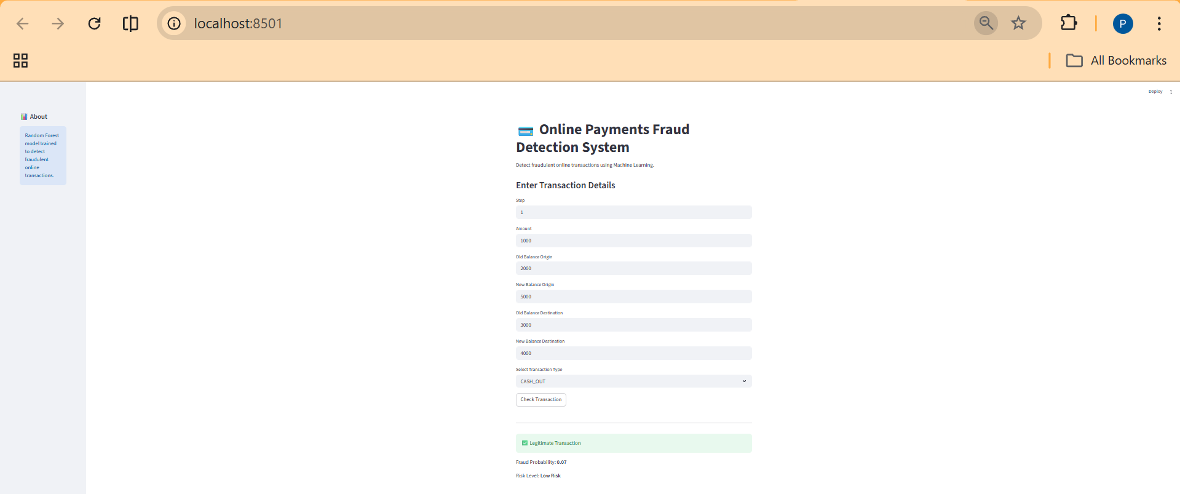
Input Fields Provided to User
- Step
- Amount
- Old Balance Origin
- New Balance Origin
- Old Balance Destination
- New Balance Destination
- Transaction Type
5.2.2 Input Validation Testing
Test cases performed:
Test Case | Expected Result
Empty fields | Warning message displayed
Invalid numeric input | Error message displayed
Valid input | Prediction displayed

5.2.3 Prediction Output Testing
After clicking Check Transaction, the system displays:
- Fraud Status:
  - ⚠️ Fraudulent Transaction Detected
  - ✅ Legitimate Transaction
- Fraud Probability
- Risk Level:
  - Low Risk
  - Medium Risk
  - High Risk
5.2.4 Risk Classification Logic
Probability | Risk Level
< 0.5 | Low Risk
0.5 – 0.79 | Medium Risk
≥ 0.8 | High Risk
This improves interpretability compared to simple binary output.
5.2.5 User Acceptance Outcome
The application was tested with multiple transaction scenarios:
- Normal payment → Legitimate (Low Risk)
- Large abnormal transfer → Fraud (High Risk)
- Suspicious balance mismatch → Medium Risk
The system successfully:
- Loaded trained model
- Accepted user input
- Generated real-time prediction
- Displayed accurate fraud probability

5.3 Overall Development Outcome
- Machine learning model successfully trained
- Model integrated with frontend
- Real-time fraud prediction achieved
- System tested and validated

